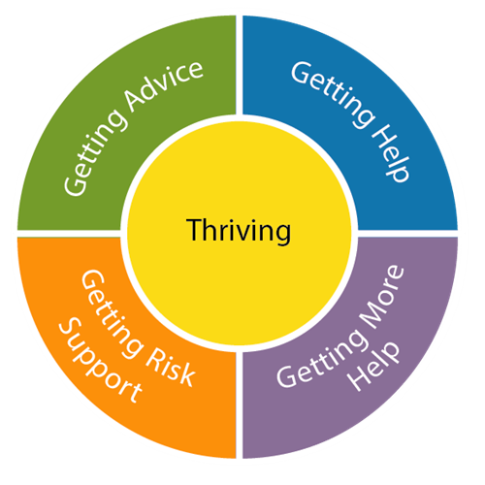
Request for “More Help” Form. Access – Community Health, Wellbeing and SEND

If you are working with a child or young person with SEND and it has been agreed with the family that “more help” may be required from a service so that further assessment or intervention can take place please complete this form.
Wherever possible this will be following a request for help discussion, consultation or meeting with the service who are likely to be able to provide this additional help.
Please complete the information below with the child/young person and family so that we have an overview of the help required.
Guidance on how to complete this form can be found: https://www.plymouthonlinedirectory.com/plymouthlocaloffer/access

Child/ young person’s name:
Date of birth:
Ethnicity:
UPN/NHS number (if known):
Address and post code:
Family contact details
- Name
- Telephone number:
- Email:

School/setting:
- Name
- Telephone Number:
- Email:
- Days and hour child attends:

Details of person making this request
- Name:
- Role
- Telephone Number:
- Email:
Please tick if the family aware of the Information Sharing Agreement and have consented to this request for involvement through Access.

Please note that we cannot process this request unless the above has been discussed with the family and the box ticked to confirm that they give consent
What is the presenting need/problem?
- Cognition and Learning:

- Social, Emotional and Mental Health:

- Communication and Interaction:

- Sensory and/or physical:

What is the desired outcome?

What have you tried already and what has been the impact?
Are any services currently working with the child or young person? If so which ones?

What are the views of the child, young person and family and what would they like to change? (Their desired outcome)

Have you had a conversation/consultation/meeting with a particular service to discuss this request for more help?

If so - which service? When/how did you have the discussion and what was the outcome?

What additional information have you included as evidence to support your request? Please tick and attach as appropriate.
Graduated Approach to Inclusion (GATI) or Early Years Graduated Approach to Inclusion (EY GATI) documentation e.g., SEND Multi Agency Support Plan (MASP)
Other assessments relevant to child’s needs e.g. Early Years Foundation Stage (EYFS) assessments, communication interaction assessments, Ages and Stages Questionnaire (ASQ)
Early Help Assessment Tool (EHAT) documentation
Other

Please send completed forms to: Accessearlyhelp@plymouth.gov.uk

This information will be processed in line with the principles of the Data Protection Act 2018 and stored for a period of 25 years. You have certain rights under the Data Protection Act and the EU General Data Protection Regulations (GDPR), which include the right to access, rectification and erasure. To enforce these rights or enquire about any other aspects of data protection, please contact Data Protection Officer, Plymouth City Council, Ballard House, West Hoe Road, Plymouth Pl1 3BJ. Email: dataprotectionofficer@plymouth.gov.uk
Plymouth City Council is registered as a data controller with the Information Commissioner's Office (registration number: Z7262171). The Council’s full Privacy notice can be found at: https://www.plymouth.gov.uk/aboutwebsite/privacypolicy

