Task Breakdown
Support students to access classroom activities with this breakdown sheet.
What do I need to do?

What equipment do I need?
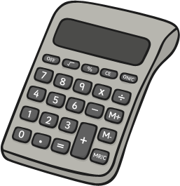
- Activity sheet
- Dictionary
- Class book

- Text book
- Pencil case
- Calculator
- Planner

Start Time: Finish Time:
First, I need to:

Next, I need to:

Last, I need to:

Do I need to finish any of this activity for homework?

I will have minutes of free time. For free time, I can:

