The Plymouth Trauma Lens
In shaping a vision for the city, the Trauma Informed Network worked collaboratively to comprehend the science of trauma and how it related to the local city context, in order to better understand what a trauma informed approach should look like. An essential metaphor emerged that highlighted a shared sense that the world once viewed through the lens of trauma, is transformed and becomes impossible to ignore. This led to the creation of the Plymouth Trauma Lens, as a model that defines and captures the underlying Principles, Core Values and supporting Standards for a trauma informed city.
The Principles – The 5Rs of becoming trauma informed
The principles for becoming trauma informed reflects the existing 5Rs approach that is in common use internationally, in developing trauma informed communities and systems that are able to:
- REALISE - what trauma is and how it can have wide spread impact for individuals, families and communities.
- RECOGNISE – the signs and effects of trauma in individual people, families, groups, and communities. This includes the workforce within organisations that deliver services.
- RESPOND – by integrating knowledge regarding trauma informed approach into policies, procedures and practice.
- RESIST - re-traumatising people and communities by actively seeking to avoid situations where traumatic memories might be re-triggered, and seeking to de-escalate & diffuse potentially traumatic interactions when they occur.
- RESILIENCE – is promoted in supporting individuals and communities to cope with and adapt to adversity, and have the strength to challenge situations where it might occur.
The Core Values & Standards of a Trauma informed Plymouth
The 5Rs are the framework that supports the 5 Core Values for a trauma informed Plymouth, as identified by the Trauma Informed Plymouth Network partnership. These values are enhanced by supporting Standards that describe a trauma informed city as one that is Safe and delivers Person Centred responses that are Kind; in which communities and professionals work Collaboratively with each other, and their services users; and are focused on Empowering and encouraging each other to innovate and transform culture.
The Plymouth Trauma Lens is intended to be an overarching tool in which the 5 Core Values and aspirational Standards can be applied at the individual level (for people accessing a service or responding to a need), at a team or departmental level, at an organisational, or community level, and at system level. The central premise of the Plymouth approach is that a trauma informed city derives from a person, seeing the world differently through the trauma lens and becoming empowered to make a difference.
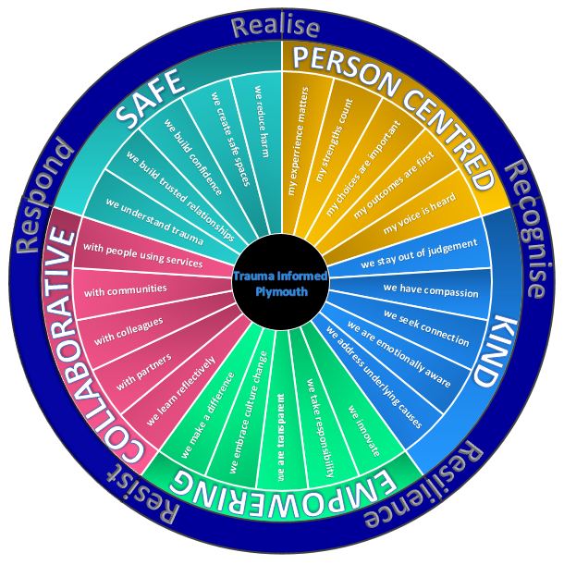
Plymouth through the Trauma Lens
Safe
For people affected, the legacy of developmental trauma, can make the world feel like an uncertain and unsafe place, for a lot of the time. Evidence suggests that trauma can impair the development of higher brain functions, preventing the ability to emotionally self-regulate and locking a person into an anxious, fight, flight, or freeze response. This is particularly the case when a person is confronted with unfamiliar, or new experiences and surroundings.
Key to a trauma informed approach is to recognise this harmful legacy of trauma and to enable those affected by trauma to feel safe. This includes understanding the triggers for anxiety within specific environments, and seeking to reduce the potential for further harm, or re-traumatisation, by creating safe environments that help to alleviate anxiety. A safe place can be as simple as creating the right physical setting where professionals work with people needing their support, or making the choice to meet in a place where they feel comfortable. However, it can be more complex and recognise how a particular context such as a family, a school, or a community may impact positively or negatively on a person’s sense of safety.
‘Relationships matter: the currency for systemic change was trust, and trust comes through forming healthy working relationships. People, not programs, change people’ – Bruce D Perry
Healing from trauma occurs within the context of relationships, within families and communities, but also with supporting professionals. The role of those relationships is to provide physical and emotional safety and to bolster the courage to tolerate, face and process the reality of what has happened. Safe relationships build confidence, resilience and trust in those affected by trauma. Each interaction is an opportunity to show someone that they are valued and to help build self-esteem. They require a developed workforce, and an educated community which can realise not only the damaging impact of trauma, but the transformational impact of positive relationships in helping people overcome it.
A community or workforce which feels safe and resilient is one of the cornerstones of a trauma informed approach, this entails being mindful of the potential impact of vicarious trauma and ensuring effective, compassionate support systems are in place alongside an emphasis on the benefits of self-care.
A sense of safety may take time to develop and people and communities affected by trauma might not respond positively to change at first. New approaches involve a time for transition as changes can be frightening. Creating safety takes time and even when it begins to develop people affected by trauma may still struggle. Becoming trauma informed is not a quick fix, and we will not always get our responses right. We should take some comfort in understanding that safe spaces are ones in which you can make mistakes.

Person Centred
A trauma informed approach is centred upon a universal precaution that assumes that anyone may be affected by childhood adversity and trauma. This is true for both the users of services, the wider community, but also professionals delivering services.
As we recognise that experiences of trauma can lead to increased anxiety, which in turn may result in challenging or crisis-driven behaviours, our focus needs to shift away from these behaviours and toward the person that requires our help. In considering, ‘what has happened to you?’ we acknowledge the deep experience that has affected and marked their life journey.
Yet while we are aware of how trauma can create a negative legacy, we also recognise that those we encounter are continuously surviving it and acknowledge they have strengths, characteristics, and assets that can be built upon. In building trusting relationships we need to give people choices in how services will be delivered and focus on the outcomes that best meet their needs, rather than those that enable an agency or service outcome to be delivered.
A trauma informed approach is about connecting with hearts and minds. While it is important to respond from a position of knowledge, expertise and evidence, we should be careful to not discount the expertise that comes from living with, or closely supporting people who have suffered trauma. There should be a deeper appreciation of how families, community groups, and third sector organisations can be specialists from experience, and as a result may offer strengths & skills that services cannot provide when seeking to frame a response to a person or community affected by adversity.
‘We readily feel for the suffering child, but cannot see the child in the adult who, his soul fragmented and isolated, hustles for survival a few streets away from where we shop or work’ – Gabor Mate
A person-centred approach also recognises the importance of wellbeing within our workforce. It understands how they may be affected by their own experience of trauma, and that of their clients. It recognises that trauma is not about ‘them’, but about ‘us’, and gives a voice to those that have experienced trauma.
To develop a person, a team, an agency, a community or a system that meets the needs of those who are affected by trauma, is to make a shift to becoming fully person centred, with efforts made to listen to what is important in the narrative of the individual, should they chose to share this, rather than what fits our service criteria or objective. In doing so not only do we become safer and more compassionate towards those who have experienced trauma, we become a better, more relationship focused service, or community for those who have not.
To be person centred means working with individuals and communities on their priorities, starting where they are at and facilitating the lightening of their load.

Kind
For those affected by trauma, building stable social and emotional attachments can be difficult. If the world can feel an unsafe place, so too can the people you encounter within it. Meeting new people and engaging with unknown professionals can trigger great anxiety, or awaken difficult sensory memories, even if they are there to help. People affected by trauma can become closed-down and withdrawn, appear resistant, or otherwise overly compliant as they struggle to manage these unfamiliar encounters.
The relationships we seek to establish can provide physical and emotional safety for those who have experienced trauma, including safety from feeling shamed, admonished or judged. A critical aspect of a trauma informed approach is about staying out of judgment, and allowing natural consequences to follow from challenging behaviours rather than being punitive in our response. Even when we are required to hold people to account we should do so with compassion, with a view to maintaining a positive relationship.
In seeking to create a meaningful connection with someone for whom relationships may be immensely challenging we should be driven by empathy. This involves perspective taking, connecting with the experience of those who use our services, while acknowledging how our own difficult experiences of trauma might be evoked. We need to recognise that in the challenging behaviours and emotions we encounter in others, what we see on the surface might not reflect the deeper and more vulnerable emotions inside. We need to understand that behaviour is a form of communication and when we encounter anger, aggressive and impulsive actions in those who have experienced trauma, often the underlying emotions are fear and anxiety.

‘I define connection as the energy that exists between people when they feel seen, heard, and valued: when they can give and receive without judgement; and when they derive sustenance and strength from the relationship’ – Brené Brown

For some people who have experienced trauma, their ability to manage competing demands or expectations placed upon can be immensely challenging. With this awareness we can continue to hold the person in mind even when their conduct may be difficult to deal with, yet needs to be addressed. We can resist being behaviour focused and seek to identify why someone finds themselves in difficulty.
Having empathy, or simply being kind, is a crucial factor in fuelling connection and creating wellbeing. It should be the basis of all of our relationships, not only those with users of our services, but also with our colleagues and peers, with those we supervise, and also with our partners and our communities.

Collaborative
Becoming trauma informed is to become both person and relationship focused. As such it is about working together and collaborating to achieve the best possible actions for those who use our services. When people have experienced trauma they may struggle to engage with us, feel invisible, or have difficulty in regulating feelings regarding a loss of power and control. They need people to accompany them on their journey, to establish trusted relationships, help them find their voice, and to empower them to make choices for themselves.
Being collaborative is also about being mindful of how our colleagues in other parts of our agency are seeking to deliver services, and ensuring a properly joined-up and consistent approach. In the same manner, where our partners in agencies or communities are already engaged, we need to make sure that we understand each other’s purpose and the potential strength of an integrated approach. This requires mutual trust, and a recognition that others may have the most trusted relationship through which we might better achieve the outcomes we desire.
Being trauma informed recognises that our own agencies and our multi-agency systems can also traumatise, particularly when multiple professionals are involved with a person or a family. A true partnership approach should seek to resist re-traumatisation; by seeking the most proportionate and least intrusive interventions; avoiding where possible a narrow focus on single-agency outcomes; and focusing instead upon a fully coordinated, integrated and compassionate response in order to help people feel safe and supported. We should also avoid a ‘one-size fits all’ approach to delivering our services.
‘Change will not come if we wait for some other person or some other time. We are the ones we’ve been waiting for. We are the change that we seek’ – Barack Obama
Collaboration is also about understanding the perspective of our partners and recognising their experience. It is about learning together reflectively; sharing skills and allowing best practice to be shared; while challenging each other with consideration to enable excellence to flourish.

Empowering
A deep experience of trauma may leave people feeling like they have no control and as a result they can become disempowered. A response to an unsafe and scary world might be to avoid situations that cause anxiety, or seek to manage them in order to minimise the fear they invoke. In creating a sense of safety, being focused on the person, creating connection through empathy, and collaborating with people to achieve the best outcomes for them, we seek to be empowering, helping them to build resilience to support healing and move forward with hope.
Trauma informed teams, departments, communities and agencies have at their heart trauma informed people. In becoming trauma informed people are able to recognise they can make a difference to the people they work with. In working with others we become empowered to make a difference. With this understanding we can start to take personal responsibility and identify new ways of working within our teams so that we can begin to transform our culture, step by step, and layer by layer.

This was identified within a consultation with Devon & Cornwall Police - Independent Advisors Group (IAG) at their annual conference at Buckfast Abbey on 13.02.18. Independent Advisors represent a wide-range of diverse communities and those within protected characteristics groups.

