SEND Assessment Toolkit
This toolkit is designed to further support class teachers in the identification and understanding of individual children’s needs in their classrooms. This should be used in conjunction with teacher assessments and assessment practices already in place as school good practice.

Cognition and Learning
Name | Summary | Implementation
Diagnostic Reading Assessment  Sounds Write / Phonicbooks.co.uk | A diagnostic tool for children who have not secured phonics by the year 2. This assessment will help to determine from which point the teacher should start teaching. The ‘Recommendations’ sheet will match suitable decodable books (from the Phonic Books range) to the reading level of the pupil. | How to use this Diagnostic Assessment:  1. Cut out the Reading cards below. The pupil should read them in the sequential order. The teacher’s sheet is for the teacher to record the pupil’s responses.  2. Ask the pupil to start with sounding out the letters at the beginning of the assessment. Note if the pronunciation of the sounds is ‘precise’ (no ‘uh’ after the consonants). Is the pupil using letter names instead of sounds?  3. Explain to the pupil that the words in lists 2-5 are nonsense words which help to assess decoding skills. There is a symbol of an alien to demonstrate this.  4. If the pupil starts to struggle, complete that section for diagnostic purposes. The teacher will need to use their judgement as to whether to start at this point or to start from the previous section to build up the confidence of the learner.  5. Record what the pupil has said. This will inform the teacher about the pupil’s reading strategies.  6. Use the ‘Recommendations’ sheet to see where to start and which books to use with your pupil.
Fresh Start  Read Write Ink | Fast-track catch up programme for years 4,5,6 pupils reading below ARE and/or pupils with SEND | Download the following from the Ruth Miskin Training School Portal:  • Assessment Pupil Sheet – one copy of the assessment for each person carrying out the assessment (see pp.20-24 for Assessment 1)  • Individual Record and Assessment Guidance – one for each student (see pp.25-27)  • School Assessment Record (available online)  • Individual Progress Record (IPR) – one for each student (see p.28)  • Pupil Progress Tracker (available online)  Before you start, read the assessment instructions on the Individual Record and Assessment Guidance.  1. Ask the student to read the Assessment Pupil Sheet.  2. Use one Individual Record and Assessment Guidance sheet for each student. Mark off the sounds, words and passages they can read and then determine their starting point.  3. Count how many students are at the same challenge point and record on the School Assessment Record. Use this information to group up to four students together, if they have reached Module 14.  4. Transfer each student’s starting point to the Individual Progress Record (IPR). Share with the tutor so they know what to teach. They will use the IPR to highlight the sounds, Word Time progress, Module and Red Words that the student has learnt to read each week.  5. Complete the Pupil Progress Tracker. Date the column corresponding to each student’s assessment outcome to track individual progress.  6. Repeat this process to assess and organise students for teaching every half-term.  Note that Assessments 1, 2 and 3 are interchangeable and it is important to rotate them. Assessment 1 is provided on pp.20–24. Assessments 2 and 3 can be downloaded from the Fresh Start pages of Oxford Owl (www.oxfordowl.co.uk/for-school/read-write-inc-fresh-start). 203522_RWI_FS_HB_ASSESS_pp18-28.indd 19 03/12/2021 16:03 SAM
Dibels Assessment | A set of procedures and measures designed to assess early reading skills. A set of 1-minute fluency measures that can be used for universal screening, baseline assessment and progress monitoring. (based on American Grades but covers year 2 - 6) Translates words correct per minute to percentiles. | Official DIBELS Home Page | DIBELS® (uoregon.edu)
Single Word Spelling Test | Diagnostic Spelling Tests which can provide a Spelling Age, and Standardised Score.  Further diagnostic materials and assessments are also included in the pack to support interventions and tracking progress. | The Diagnostic Spelling Test is administered per National Curriculum tests –  Test 1 – Ages 5-7  Test 2 – Ages 7-9  Test 3 – Ages 9-12  There are 2 tests for each which can be used in parallel forms to support progress measurements.  Diagnostic Overlays can be used to support identification of needs, precision teaching and targeted follow up tests to measure progress.  These are available within the Pack alongside the instructions.
Individual Spelling Audit | A tool to inform specific spelling gaps.  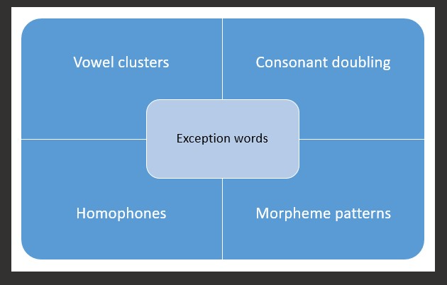 | Use the Pupil Spelling Inventory with an example of the child’s extended writing. Record any spelling errors within the 5 categories. This can help to identify specific gaps for an individual child or group of children which can inform PLPs, intervention and/or classroom curriculum.
Morrison-McCall Spelling Lists | A reliable assessment tool containing 8 normed tests, each of equal difficultly used to determine gaps in children’s spelling and identifies a spelling age. | https://professionaldevelopment.alicenine.net/pluginfile.php/19248/mod_resource/content/9/Morrison-McCall_SpellingScaleR.pdf
Spelfabet  Similar looking word test  » The similar-looking word test (spelfabet.com.au) | Assessment useful for children who seem to read well but spell poorly. They can typically comprehend easy books but when books get harder and/or contain a lot or new vocabulary they start to struggle.  Can help to identify if their reading is based on the beginnings and ends of words rather than a phonic approach to decoding e.g. a child who reads compete and complete. Also, children who identify letters but not their order e.g. they read felt as left | Ask children to read some similar looking words like below:  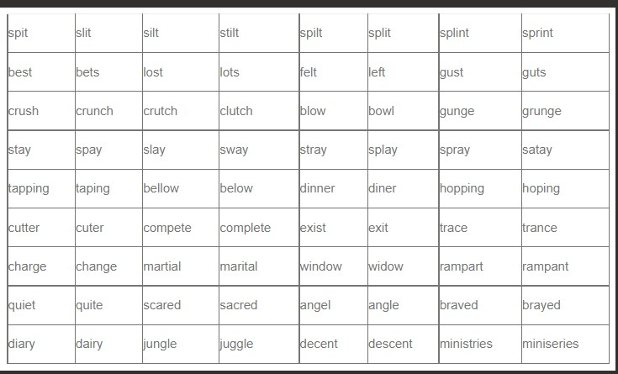  If this identifies problems with this area there are some link activities available https://wordwall.net/teacher/666616/spelfabet/folder/321367/similiar-looking-words
Handwriting Legibility Scale | Simple scaling tool useful to obtain an overall impression of handwriting using a 5-point scale. Designed for use with year 5/6 children but could be used with year ¾. | https://bit.ly/39VJdf2  The assessment should be based on a piece of ‘free writing’ produced by the child, ideally on an A4 sized sheet of lined paper. The text should be approximately 10 lines in length.  The focus of this scale is on legibility of the handwriting. However, since speed is also an important element you should also time the writing task. Start to time when the child begins to write and mark their text after six minutes. This will give you a record of the child’s rate of production, useful for comparing against other children of the same age and for monitoring performance over time.  Sometimes legibility is affected by spelling errors. You should therefore indicate below whether the child has made spelling errors in the text.
Non-Negotiables by Year Group  Granular steps | These can support identification of basic number strengths and difficulties and can provide a starting point for developing confidence and core skills.  Saved in Maths mastery folder. Gives a breakdown of topics into smaller steps to provide scaffolding. | Using your teacher assessment of a child – start with the most appropriate Year group for the individual learner. So, for a child in Year 4, it may be appropriate to go back to the Year 2 non-negotiables.  Identify the gaps for the child and use these to target through daily precision teaching-based interventions – tracking progress against the core skills.  Useful when planning lessons to break lessons into smaller chunks for children who are not grasping the learning objective. Great for pre teaching or post teaching to ensure they have the necessary knowledge to move on.
Flashback assessments | A set of questions which revisit previous learning to give recall. | These can give children opportunity to practise and retain key skills from the current and previous units. This aids retention of facts.
Fluent in 5  Quick 6 | Saved in Maths mastery folder | Gives children opportunities to practice key concepts in 5 minutes. Good for recall and retention.
Ready to progress criteria.  Free R-t-P online quizzes | A short assessment to test whether children have retained key knowledge from the unit.  Can be downloaded from effective maths. Assessment tool for the R-t-P criteria. | Children complete the tests, saved in maths mastery/documents/assessment. Teachers then use the R-t-P mapping document to map out what questions children got correct and those which are wrong. This then highlights areas which may need to be revisited, either with the whole class, groups or individuals.  Children can access these tests via a tablet. It will ask for an email address and password. Use teachers work email address as the system will email you the child’s results. Give each child a number which can act as their username/password so they are easily identifiable. Ready to Progress Intervention Maths Curriculums & Lesson Plans (arkcurriculumplus.org.uk)
Ready to progress interventions.  Ready to progress intervention programme. | Saved in the maths mastery folder. Activities to support intervention based on each ready to progress criteria.  Paid resource, approx. £500 per school. Assessment and bespoke intervention programme. | Activities to support intervention based on each ready to progress criteria.  Ready to progress intervention programme, aligned with EEF research. Gives over 140 pupil-facing videos with an activity bank and intervention guidance support. Assesses children using the rtp then suggests a programme based on their scores. This then provides the teaching resources, CPD and support needed for the children.
Dyscalculia Assessment | If a child is performing significantly below ARE or making no progress in mathematics despite precise targeted intervention, then it is possible to use The Dyscalculia Assessment to support understanding of needs.  It is an Informal diagnostic assessment and can provide detailed overviews of strengths and weaknesses. | The assessment activities should be carried out 1:1 over several (short) sessions and can be completed by the class teacher or an experienced TA. It should be used in conjunction with the Maths non-negotiables, and you will find there is some cross over. The advantage to using this tool is the assessment forms which are used for each skill with key questions and observations included to support identifying strengths and weaknesses.  I would suggest these are competed over 2-3 weeks and when completed go through the assessment forms with the school SENDCo to support analysis and next steps.

Communication and Interaction
Name | Summary | Implementation
Speechlink: Speech and Language Link - support for SLCN  Subscription Required | Speech Link is used to identify and support children with developmental speech sound difficulties. Suitable for children aged 4 to 8 years, Speech Link helps demystify speech work and helps support staff work effectively with children’s common speech sound errors. | Online Screening assessment with detailed report and recommended interventions provided.
Infant and Junior Language Link  Subscription Required | Both assess the key elements of understanding language. | The Infant Language Link assessment is delivered online. It consists of 64 items presented across 8 sub-tests: Concepts, Verb Tenses, Instructions, Pronouns, Negatives, Questions, Verbal Reasoning and Association.  Junior language Link is also delivered online and focuses on higher level language skills.
The Communication Trust  Universally Speaking Booklets and Checklist | The Communication Trust have developed a series of booklets designed to support class teachers in the identification of SLCN for individual pupils | https://www.thecommunicationtrust.org.uk/resources/resources/resources-for-practitioners/universally-speaking/  Use observations and teacher assessments to complete the checklist and refer to the booklists for developmental profiles. These can then be used to support focused interventions and referrals to SALT
Blank Levels of Questioning | The Blank Language Model (Blank, Rose and Berlin,1978) has transformed a complex area of language into 4 more simple levels of questioning. This model helps to support and further develop a child’s understanding of abstract language and verbal reasoning. It gives us a tool to be able to develop children’s language development in a structured and developmental way. It allows us to support children’s understanding at the right level or to challenge children at the appropriate level. This model moves from understanding and answering concrete questions to more abstract questions. Children need to understand and respond to all these levels of questions to function easily within a year one classroom. | Teachers can use observations and specific tasks to support understanding of what level children are regarding a child’s language development. In the pack there is further guidance of activities which can be used and there are also support packs which can be accessed from TWINKL to support and provide models.
Autism Questionnaire | Devon Integrated Children’s Services  Screening Questionnaire for children and young people where there is a concern about possible Autistic Spectrum Disorder | Where teachers/parents are considering ASD as a need this can be completed by both to support discussions, understanding of behaviours being presented and support future referrals to additional services including diagnosis.
TALC  Test of Abstract Language Comprehension | The TALC is based on the Language of Learning Model which has informed the Blanks Level of Questioning. The developmental sequence can be used to ascertain the level of abstract language a child can understand. | There are 2 parts to the TALC Assessment  Picture and the General Assessment – they should be carried out by an adult that the child knows/trusts.  Full Administration details are included in the pack.

Social Emotional and Mental Health
Name | Summary | Implementation
Boxall Profile: SEMH Assessment & Emotional Behavioural Toolkit for Children - Interventions & Strategies (boxallprofile.org) | Online Assessment of a Child’s SEMH Development | There are two Boxall Profile Tests - one for children (nursery/primary school pupils), and the other for young people (secondary school students), which the Online Boxall Profile automatically sets according to the date of birth inputted by the member of staff. On completion, the scores of each individual student are compared to the standardised emotional literacy scores of "competently functioning" children of a similar age group.  Individualised, achievable targets for social and emotional aptitudes are then set for the student which are reviewed and re-assessed periodically. Both profiles have two sections, each consisting of a list of 34 descriptive items.  Section I: Developmental strands  This measures progress through the different aspects of development in the student's early years- the first assessing the child and young person's organisation of their learning experiences, the second, their internalisation of controls.  Section II: The diagnostic profile  This consists of items describing behaviours that inhibit or interfere with the child's satisfactory involvement in school- self-limiting features, undeveloped behaviour and unsupported development. They are directly or indirectly the outcome of impaired learning in the earliest years. The earlier such children are identified the greater the hope of being able to address and remediate their social, emotional and behavioural difficulties by offering patient and supportive teaching.  Targets can be created and an Intervention programme which can be tracked.
EYFS PSED Statements | Early Years Statements which can be used with children of all ages to support further understanding of SEMH development and their Emotional Age. | Teacher and other adults using observations and knowledge of child to highlight where the child is on the statements which will then provide a guide to the child’s emotional age. Statements can be used to provide outcomes for PLPS and to measure progress against interventions.
Emotional Literacy Nurture Assessments – paper based and excel format | Emotional Literacy Assessment Tools for the following areas:  Anger, Anxiety, Emotional Awareness, Friendships and Relationships, Growth Mindset and Behaviour for Learning, Independence, Self Esteem, Social Skills. | These assessments form a guide to assessing a child’s social, emotional and behavioural skills. These assessments should be filled in by a teacher or someone who knows the child well in school. Each area is on a separate sheet so you can choose to either do all of them or just the areas you feel there is a problem.  There is also a pupil self-assessment that the child fills in with the help of an adult. This could be done in your first session with the child or if working in a group it could be your first activity.  This data will show:  • Show weak areas so will inform planning for the ELSA/Learning mentor  • Show strengths that the ELSA/Learning mentor can use in their work with the child  • Show a difference post assessment so showing the impact the ELSA/Learning mentor has had in supporting the child.  Use the table to give an overview of all the assessments.

Physical and/or Disability
SWFT NHS OT Programmes | Children’s Occupational Therapy has designed 6 programmes to choose from, arranged in a developmental sequence.  Starting with foundation skills in movement and body awareness, moving on to more complex fine motor and pre-writing skills, all the way up to handwriting fluency.  Each programme is designed to run half termly (6 weeks), with 3 sessions (approximately 20-30 minutes) per week.  The programmes are ideal for a small group setting and the booklets contain all the information you need to deliver the programmes, with a session-by-session plan | A simple checklist (in assessment toolkit) helps you decide which programme would be most suitable for each child, and there are accompanying baseline and outcome measures, and a form for recording each session.  Detailed intervention programmes can all be downloaded from the following link South Warwickshire University NHS Foundation Trust: How can I help the child at school? (swft.nhs.uk)

