
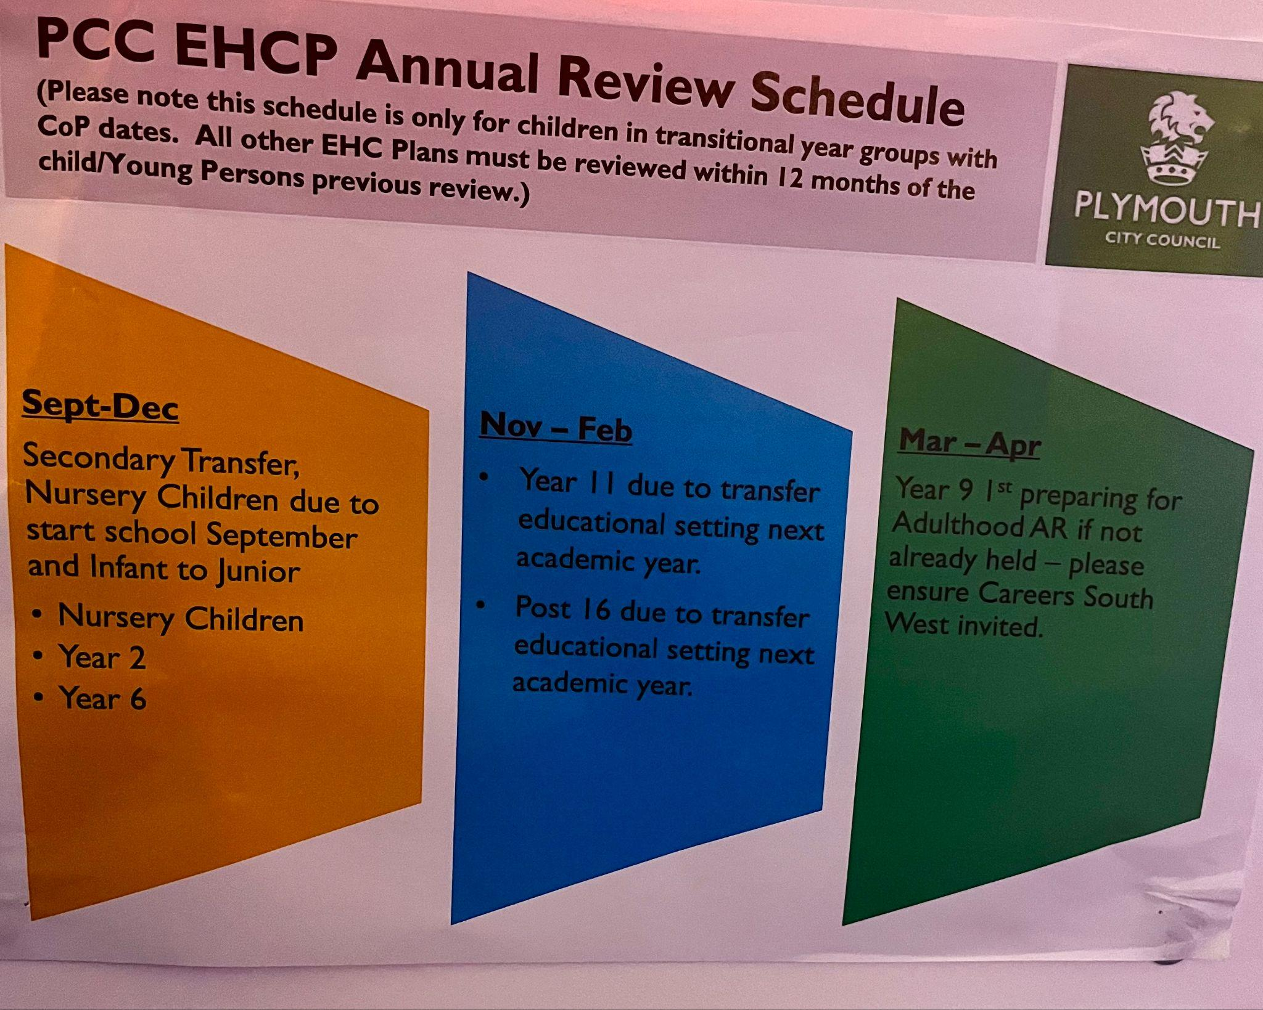
2024/25 SENDCo Calendar
Autumn Term

Week Commencing | Assessment  GL assessments  Dyslexia screening  Access arrangements  BTEC/GCSEs  Blank level screening | Reporting  SEND lens data analysis  EHCP annual review timeline  APDR  Governor SEND contribution for report  Transition Portal  Enhanced Transitions  Year 6 transition EHCP release day | Q/A  EP/CIT PCMs  MAST PLP PCMs  Finance EBM  SEND register review  Entry/Exit data HIVE and PSH  SEF  RSAT Inclusion lead meets  Learning walks  Attendance Challenge Meetings  PCC SENDCo meetings  . | Weekly meetings -Ally  SLT -MONDAY PM  Attendance AM  RSLs - TUESDAY PM  Pastoral/SEND weekly triage -AM  Teach Meet sessions  CPD - WEDNESDAY PM  SEND Tours - Thursday PM  SEND faculty - FRIDAY PM  Leads meeting (SENCo, Safeguarding,Pastoral) - Friday AM  SENCO supervision with MBi - Friday AM
2nd-4th September 24 | Trust Inset Days, set up spaces |  | SEND information report finalised and added to the website | Vision & Values SLT Whole staff
9th September 24 | BTEC TECH AWARD ALL PSA’s released for Dec 24 assessment | *Summer results data analysis Subjects/Faculty/SEND | SEF RSL  SEND register review
16th September 24 | HIVE/Thrive ENTRY DATA  Speech and language blank level assessments |  | Finance EBM  Trust Inclusion lead meets
23rd September 24 |  |  | - week 1 of 3 Observations to inform appraisal  EP/CIT PCMs  MAST PLP PCMs
30th September 24 | GL assessments begin English, Maths Science |  | - week 2 of 3 Observations to inform appraisal
7th October 24 | Dyslexia screening |  | - week 3 of 3 Observations to inform appraisal
14th October 24 |  | APDR CYCLE | (Deadline for all appraisal meeting paperwork (31st Oct) external)
21st October 24
28th October 24 | Half term
4th November 24 | Y10-11 BTEC Controlled Assessments commence  Y11 Mock Series 1 Starts | Governor SEND contribution for report | MAST coordinators meet
11th November 24 | HIVE/PSC Monitoring DATA  Speech and language blank level assessments |  | - week of RSL & SLT LW
18th November 24
25th November 24 |  | Mock data deadline in Arbour (24th Nov)
27th November 2023 | Y11 Performing Arts Assessment  Access arrangements testing | Arbour HT2 data window 7-11 opens (27th Nov) | RSLs QA Mock data
2nd December 24 | Y10-11 BTEC Marking & Standardisation | Arbour data window closes (7th Dec) | - week of RSL & SLT LW
9th December 24 | Y10-11 BTEC deadline for marks to be submitted | HT2 Reports communicated home (13th Dec) | RSL HT2 data QA deadline  SEND Lens data analysis KS3 and year 10
16th December 24

Spring Term
Week Commencing | Assessment | Reporting | Q/A | CPD
6th January 25 | BTEC AWARD PSA’s released for May |  | SEND register review
13th January 25 | HIVE/PSC Monitoring DATA  Speech and language blank level assessments |  | Finance EBM
20th January 25 |  |  | Trust Inclusion lead meets
27th January 25 |  |  | EP/CIT PCMs  MAST PLP PCMs
3rd February 25 | Year 11 Mock Series 2 starts |  | - week of RSL & SLT LW
10th February 25 | End of Y11 Mock series 2  Access arrangements testing | APDR CYCLE
17th  February  2025 | Half term | Year 6 transition EHCP release day
24th  February 2025 | Y10-11 BTEC award controlled assessment opens
3rd March 2025 | Year 11 English Speaking & Listening Component week | Mock data deadline MONDAY | - week of RSL & SLT LW
10th  March  2025 | HIVE/PSC Monitoring DATA  Speech and language blank level assessments | Governor SEND contribution for report | RSL Mock Data Q&A
17th  March  2025 |  | Arbour HT4 data drop 7-11 window opens | MAST coordinators meet
24th  March  2025 |  | Arbour HT4 data drop 7-11 window closes | RSL data analysis deadline 22nd March  SEND Lens data analysis KS3 and year 10  - week of FL & SLT LW
31st  March  2024 | Y10-11 BTEC Award controlled assessments close | HT4 reports communicated home | Deadline for mid year appraisal review to be completed
7th-14th  April  2025 | Easter holiday

Summer Term
Week Commencing | Assessment | Reporting | Q/A | CPD WEDNESDAY
21st  April  2025 | HIVE/PSC Monitoring DATA  Speech and language blank level assessments | Transition Portal  Enhanced Transitions | Y10-11 BTEC Marking & Standardisation begins  SEND register review
28th  April  2025 | GCSE Art exams 24th & 25th |  | Finance EBM
5th  May  2025 (BH Monday) | GCSE Photography exams  30th April & 1st May | Y10 & Y11 BTEC marking and standardisation finishes - deadline for marks to be submitted | Trust Inclusion lead meets
12th  May  2025 |  | Deadline WJEC Hospitality & Catering/ Engineering coursework marks | - week of RSL & SLT LW
19th  May  2025 | GCSE Written Exams commence | APDR CYCLE | EP/CIT PCMs  MAST PLP PCMs  MAST coordinators meet
26th  May  2025 | Half term
2nd  June  2025 | HIVE/PSC Monitoring DATA  Speech and language blank level assessments | Transition Portal  Enhanced Transitions
9th  June  2025 |  | Governor SEND contribution for report  Transition Portal  Enhanced Transitions
16th  June  2025 | Y10 Mock series | Transition Portal  Enhanced Transitions | - week of RSL & SLT LW
23rd  June  2025 | Access arrangements testing | Transition Portal  Enhanced Transitions
30th  June  2025 |  | Arbour HT6 data window opens Y7-10
7th  July  2025 | HIVE/PSC EXIT DATA  Speech and language blank level assessments | Arbour HT6 data window closes | RSL data QA Deadline  SEND Lens data analysis KS3 and year 10
14th  July  2025 |  | HT6 reports communicated home
21st July (Break up 23rd July)

