Developmental Language Disorder (DLD)
DLD is a neurodevelopmental condition that causes difficulty understanding and / or using spoken language.
It is a life-long condition.
1 in 14 people (or, to think of it another way, 2 children in every class) have DLD. It’s much more common than Autism. It’s been described as ‘probably the most common disability that nobody has ever heard of’.
It can impact all aspects of life – learning, socialising, making friends, play, employability and mental health.
Here’s what to look out for in the early years:
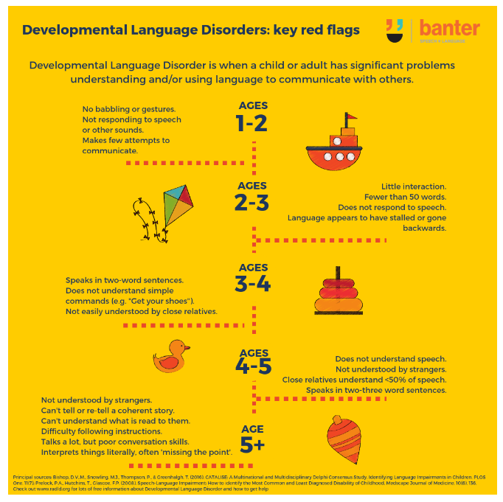
For more information visit RADLD.com (Raising Awareness of DLD)

