 CYP Case Study Support - SEND
Teacher: |  |  |  |  | Observer: |  |  |  |  |  |  |  |  |  |  | Date:
Name of student:
Lesson/Subject:
Purpose of case study:
Pen-Portrait? | Y/N |  |  |  | Risk Reduction Plan? |  |  |  |  | Y/N |  |  |  |  |  | Engagement plan? |  |  |  | Y/N
Day | Monday |  |  | Tuesday |  |  |  |  | Wednesday |  |  |  |  |  | Thursday |  |  |  | Friday
Period | 1 |  | 2 |  |  |  |  | 3 |  |  |  | 4 |  |  |  |  | 5 |  |  |  | Tutor
Year | 7 | 8 |  |  |  | 9 |  |  |  |  | 10 |  | 11
Wave of student | None |  |  | 1 |  |  |  |  | 2 |  |  |  |  |  | 3
Information about student – to be completed by the teacher prior to observation.
Known diagnosis or conditions:
Barriers to learning:
Interventions already in place:
Grades and assessment information:
Attendance:
Behaviour & achievement points to date:
Observations in lesson/class:
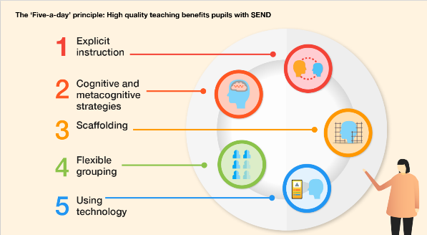

What strategies are being used?
Explicit instruction
Cognitive and metacognitive strategies
Scaffolding
Flexible grouping
Using technology
Qualitative observations:
Independence
Confidence in subject
Attitude to learning
Environmental
Social skills & relationships
Behaviour in lessons.
Other:
Student voice:
Feedback
Actions and next steps
Action |  |  |  |  |  |  |  |  |  |  |  |  |  | Who?
Follow up required? |  |  |  |  |  |  |  |  |  |  |  |  |  | Y/N

